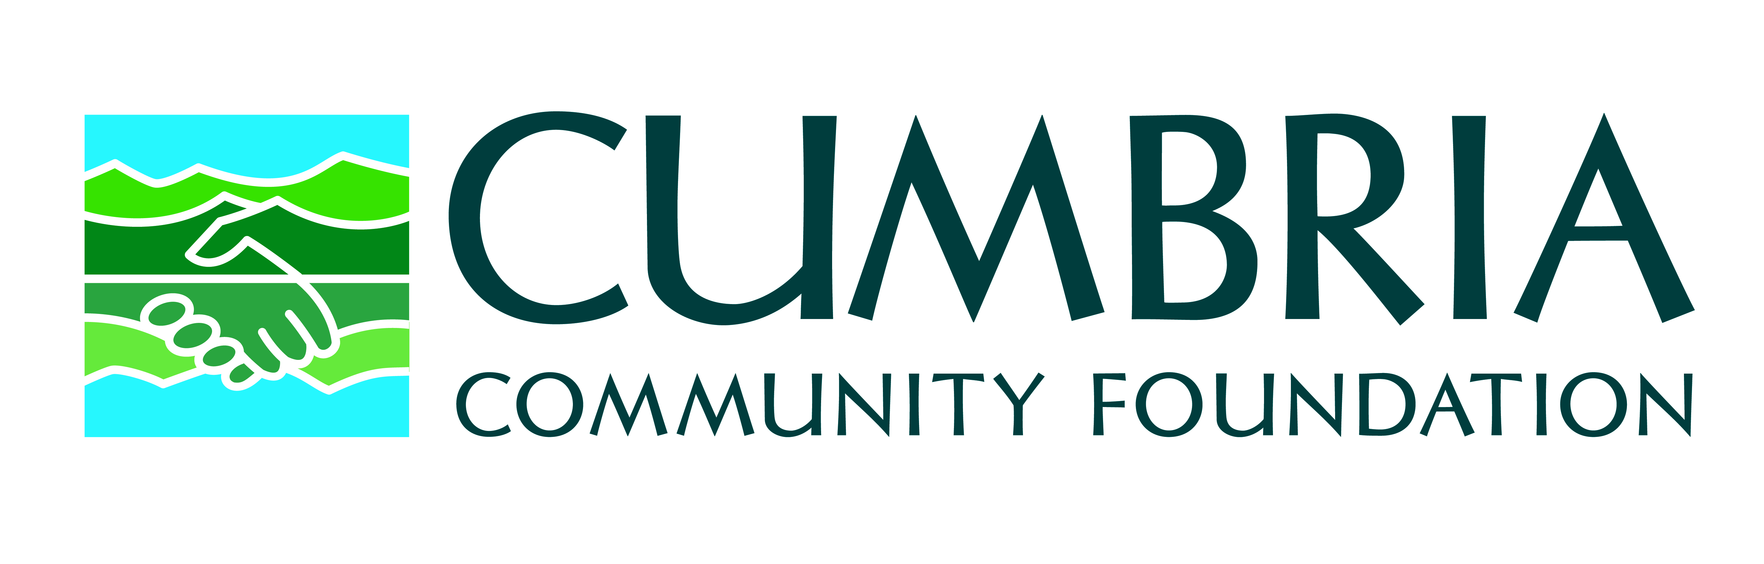
Swales Trust Application Form
(Individuals applying for Higher/Further Education Support)

Grants will normally be only for a proportion of the anticipated expenditure costs except in exceptional circumstances where full costs may be considered.

Please complete this form as fully and clearly as possible. If you have any questions, please contact Ellen Clements, Senior Grants & Programmes Officer on 01900 820824.

SECTION ONE: PERSONAL DETAILS

Mr/Mrs/Miss/Ms Full Name

Date of birth |  |  | Place of birth

Home address | Term time address (if applicable)
Postcode
Telephone | Telephone
Email | Mobile
Ages of other dependent children in household (if any)

Details of Secondary/Further Education
Dates | School/College/University attended | Qualifications gained

Please provide information about other funding, e.g., personal contribution and/or fundraising or details of applications made to the local authority or other body for grant aid or a student loan. If you have been awarded a grant/loan, please attach a copy of the notification of amount awarded with this application.

Please also tell us of additional items you may have already received funding for such as travel costs, equipment, kit, exam fees. We need to know that you will be able to complete the course if we fund your application.
Funder | Item/What for | Amount Secured
 | Total

Should you be awarded a grant, please provide details of the bank account into which you would like the grant to be paid.
Name of Payee
Name of Bank
Account Number
Sort Code

SECTION TWO: PROJECT INFORMATION

Proposed Activity/Training. Please attach a copy of the acceptance letter or offer from the college/university with this application form.

College/Training Provider
Course/Activity Title
Details:
(length of study, full-time or part-time,
location, start and end dates)
Course year: e.g. 1st , 2nd, 3rd year

What do you want the grant to pay for?

Breakdown of proposed expenditure (continue on another sheet of paper if necessary)
Cost/Item | Amount
Total amount requested

By what date do you expect the money to be spent?

Please give details of any special circumstances or specific difficulties, e.g., a disability, which you feel should be taken into consideration when the Panel considers your application.

If relevant, please tell us how your grant may help you or the wider community; for example, it may help you in a voluntary role with a local youth group.

Please note that the Foundation requires successful applicants to complete an end-of-grant report which summarises how the award has been used and what difference it has made to the applicant.

Please tell us how you heard about applying to Cumbria Community Foundation, e.g., website, school recommended, friend recommended, social media, newspaper, etc.

SECTION THREE: REFEREE DETAILS

Please give the name, position and contact details for a referee. This must be your education/training adviser.

Name
Position
Address
Telephone
Email

SECTION FOUR: ACCEPTANCE OF CONDITIONS AND CHECKLIST

In applying for a grant from Cumbria Community Foundation you agree that we can:
- Use the information you have provided to process your grant application and to administer any grant award.
- Contact you by telephone or by email if we have a question about your application.
- Request other information and/or evidence from you to clarify or confirm information given in this application form.
- Obtain information about you and/or application from other organisations.
- Check information with other sources such as your referee.
- Share information about your project with relevant fundholders, funders and/or donors.

If offered grant aid, you agree to the following terms and conditions:
- You will fulfil any conditions of your grant offer in the specified timeframe, or your grant offer will be withdrawn. Any other arrangement/s must be agreed in writing with your Grants & Programmes Officer.
- You will use the grant only for the purpose for which it has been approved.
- You will provide invoices, receipts and/or payroll documents as evidence of spend for anything over £500 and a table of costs for amounts of less than £500.
- You will notify Cumbria Community Foundation in advance of any proposed material change to your project.
- You will notify Cumbria Community Foundation if your project is delayed and/or cannot proceed.

- You will complete a grant monitoring form at the end of your project, or as required at periods during your project, e.g., quarterly, or annually for a multi-year funding award.
- You will complete additional monitoring information as requested, which may include surveys, to evidence impact and to improve grant making practices.
- You will receive, if required, a project monitoring visit from a representative of Cumbria Community Foundation.
- You may be invited to attend events hosted by Cumbria Community Foundation.

- Your grant is a donation, and Cumbria Community Foundation is not liable for the consequences of its use.
- You will keep records of expenditure for at least seven years, which will be supplied to us if requested.
- You will return your grant award to Cumbria Community Foundation if your project does not proceed.
- You will return any unspent funds to Cumbria Community Foundation at the end of your project.
- You will return the grant to Cumbria Community Foundation if you fail to advise us of the disposal of grant-aided capital items.
- Cumbria community Foundation reserves the right to reclaim any money which has been paid as the result of fraudulent or misleading claims.

- You will notify us if an allegation relating to safeguarding and/or health and safety is to be investigated or has been proved.
- You will acknowledge Cumbria Community Foundation and any fundholder/donor /funder as required on any publicity material you issue.
- If you provide us with any photos in support of your funded activity, you agree for Cumbria Community Foundation to keep and use for publicity and reporting purposes
- You will provide us with relevant case studies, and if you agree as part of the monitoring process, we may use in publicity, impact reports etc.

Please tick this box to confirm that the information provided is true and accurate and that you accept the conditions detailed above, and sign below, or type in your name and date if emailing this application.

Signature |  | Date

Parent’s/Guardian’s Signature |  | Date
(Parent’s/Guardian’s signature is required for all applicants under age 18)

Data protection: Where possible, we will communicate with you by email. We would also like to send you our e-newsletter which includes details of grant application closing dates and other information. You can unsubscribe from that e-newsletter at any time.

Please tick here if you wish to be sent Cumbria Community Foundation’s e-newsletter:

CHECKLIST

1. Have you fully completed all sections of the form?

2. Have you enclosed a copy of the offer or acceptance letter from your
college/university/training provider?

Please submit this application and supporting documents by email to grants@cumbriafoundation.org and label each document with your name and a brief description.

Alternatively, please post the application and supporting documents to:
Cumbria Community Foundation, Dovenby Hall, Dovenby, Cockermouth CA13 0PN

