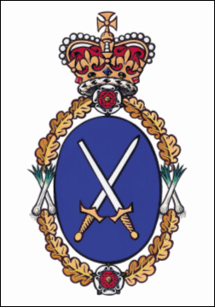

High Sheriff of Cumbria’s Morecambe Bay Charity Walk
to benefit The High Sheriff’s CRIMEBEAT FUND
with Cedric Robinson MBE “The Queen’s Guide to the Sands”
Sunday 6th July at 11:30 a.m.

ENTRY FORM
(one for EACH walker, please)

Name: _______________________________________________________________

Address: _______________________________________________________________

_______________________________________________________________

Postcode: ______________ Mobile Telephone: _________________

E-mail: __________________________ Age: ______ (16 & under MUST be
accompanied by an adult, & consent signed)

Emergency Contact Details

Name: ______________________________________________________________

Relationship: __________________________ Telephone: ______________________

ENTRY FEE: £10 for Adults, £5 for Children under 16; £2 for dogs
In the unlikely event of cancellation, it is assumed that you will not require a refund and
that your fee will go directly to the CRIMEBEAT FUND as a donation.

Declaration: By signing this registration you signify that you accept in their entirety the conditions of entry for this event, that you are in good health and know of no medical reason why you may not participate in the walk, that you enter the walk entirely at your own risk and that you completely indemnify the organisers in respect of any personal injury or incident arising as a consequence of your participation.

Walker’s Signature: ___________________________________________________________

Parent/Guardian’s Signature (if applicable): __________________________________________________

Entries by POST: Please post completed form together with your registration fee
cheques payable to: CUMBRIA COMMUNITY FOUNDATION (HIGH SHERIFF CRIMEBEAT FUND)
to:
Morecambe Bay Charity Walk
Bankhead
Newby East
Carlisle
CA4 8RA

ALL ENTRIES MUST BE RECEIVED BY 1 JULY, 2014

If you have any queries, please e-mail: hs.cumbria2014@btconnect.com

