Please tick appropriate box

I / We wish to become a Member(s) of Cumbria Community Foundation

(Minimum Annual Subscription Rates Individual £25.00, Families and Couples £50.00)

I / We wish to make a donation to Cumbria Community Foundation
Name(s)
Address (inc postcode) | Main Tel No  Mobile  Email

Subscription Due: £

We wish to make a donation of: £

Total £

I/we have made an online payment to Cumbria Community Foundation

I/we enclose a cheque made payable to Cumbria Community Foundation

Would like to donate regularly and have completed the bankers order

Please contact me to discuss my options for charitable giving

Signed: Date: / /
Gift Aid Declaration
Please tick the appropriate box
Please treat
□ The enclosed gift of £______________ as a Gift Aid donation; OR
□ All gifts of money that I make today and in the future as Gift Aid donations; OR
□ All gifts of money that I have made in the past 4 years and all future gifts of money that I make from the date of this declaration as Gift Aid donations.

I confirm I have paid or will pay an amount of Income Tax and/or capital Gains Tax for the current tax year (6th April to 5th April) that is at least equal to the amount of tax that all the charities and Community Amateur Sports Clubs that I donate to will reclaim on my gifts for the current tax year. I understand that other taxes such as VAT and Council Tax do not qualify. I understand the charity will reclaim 25p of tax on every £1 that I have given.
Signed | Date

If you pay Income Tax at the higher or additional rate and want to receive the additional tax relief due to you, you must include all your Gift Aid donations on your Self-Assessment tax return or ask HM Revenue and Customs to adjust your tax code

Privacy Notice: We do not supply our mailing list to any other organisation. We would like to send you additional information about our activities and fundraising opportunities. I would like to receive this by (please tick)
□ e-newsletters by Email
□ Fundraising Requests by Email
□ Fundraising Requests by Phone
Please return the completed form to:

Cumbria Community Foundation
Dovenby Hall
Dovenby
Cockermouth
CA13 0PN

HSBC Bank plc
Carlisle City Office
29 English Street
Carlisle
CA3 8JT

Cumbria Community Foundation
Sort Code: 40-16-22
Account: 32152967
Reference: please give your name

Office Use only

Account name to be debited:

To the Manager Bank PLC

Address

Postcode

Account Number

Sort Code - -

Please pay the sum of £ on the / / and on the same day each

year / quarter / month (circle as appropriate) until further notice or for years

Signed Date

Please return the completed form to:

Cumbria Community Foundation
Dovenby Hall
Dovenby
Cockermouth, CA13 0PN

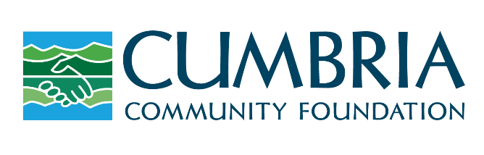

Connecting people who care with causes that matter

